Experiment Number : 02 Date:

Input and Output Statements in Java
Aim:
To understand and use input and output statements in Java using the Scanner class.
PRE LAB EXERCISE
QUESTIONS
What is input in a program?
Input is the data provided to a program for processing. It can come from sources such as keyboard, files, sensors, or network. The program uses this data to perform computations.
What is output in a program?
Output is the result produced by a program after processing the input data. It may be displayed on the screen, saved to a file, sent over a network, or used by another program.
Which class is used to read input from the user in Java?
The Scanner class from the java.util package is commonly used to read user input in Java. It reads data types like int, float, double, and String from System.in (keyboard input).

IN LAB EXERCISE
Objective:
To read input from the user and display the output using Java input and output statements.
INPUT STATEMENT:
SCANNER CLASS
- The Scanner class in Java is used to read input from the user through the keyboard.
It is available in the package java.util.
- The Scanner object reads different types of input such as integer, float, double, and string and stores them in variables.
- To use the Scanner class, it must be imported before using it in the program.
SYNTAX:
- Scanner sc = new Scanner(System.in);
Commonly Used Scanner Methods:
- nextInt() – reads an integer value
- nextFloat() – reads a float value
- nextDouble() – reads a double value
- next() – reads a single word
- nextLine() – reads a complete line of text

PROGRAMS:
Program 1: Read and Display Name
Source Code:
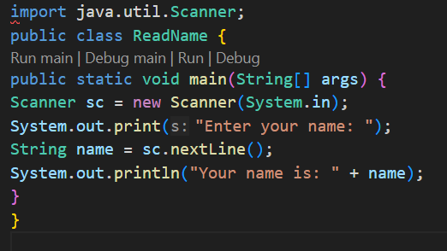
Output:
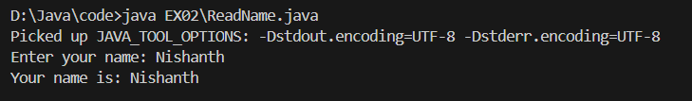

Program 2: Read Two Numbers and Print Sum
Source Code:
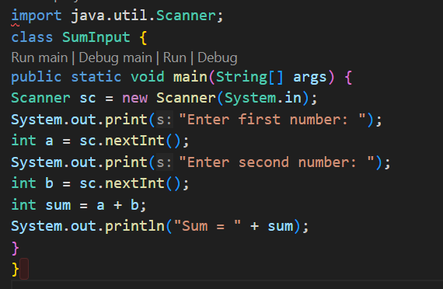Output:
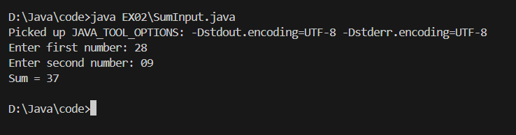

Program 3: Read Length and Breadth and Find Area of Rectangle
Source Code:
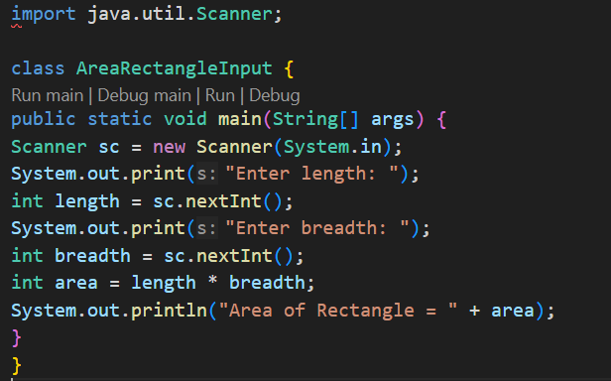
Output:
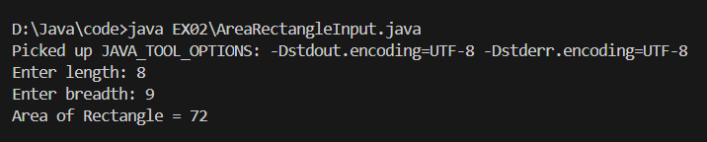

POST LAB EXERCISE
- What is the use of the Scanner class in Java?
The Scanner class is used to read input from different sources such as keyboard, files, or strings. It helps programs accept user input and convert it into different data types.

- Which package contains the Scanner class?
The Scanner class belongs to the java.util package. To use it in a Java program, the statement import java.util.Scanner; must be written at the beginning of the program.

- What does System.in represent?
System.in is a standard input stream in Java. It represents input received from the keyboard and is commonly used with the Scanner class to read user data.

- What does System.out represent?
System.out is the standard output stream in Java. It represents the console or screen where program output is displayed using methods such as print() and println().

- Name any two methods used to read input using Scanner.
Two commonly used methods of the Scanner class are nextInt() and nextLine(). nextInt() reads integer values, while nextLine() reads an entire line of text input.

- What is the difference between next() and nextLine()?
next() reads only a single word until a space or delimiter appears. nextLine() reads the entire line of input, including spaces, until the user presses the Enter key.

Result:

Thus the input was successfully read from the user and the corresponding output was displayed using Java input and output statements.

ASSESSMENT

Description | Max Marks | Marks Awarded
Pre Lab Exercise | 5
In Lab Exercise | 10
Post Lab Exercise | 5
Viva | 10
Total | 30
Faculty Signature

